If A=1 and Z=26, find it for Hard work, Knowledge and Attitude

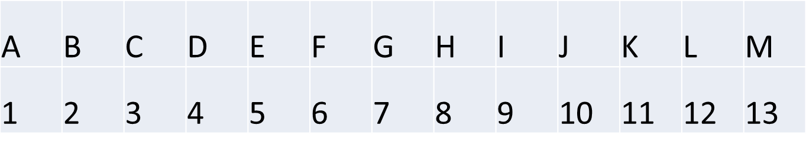

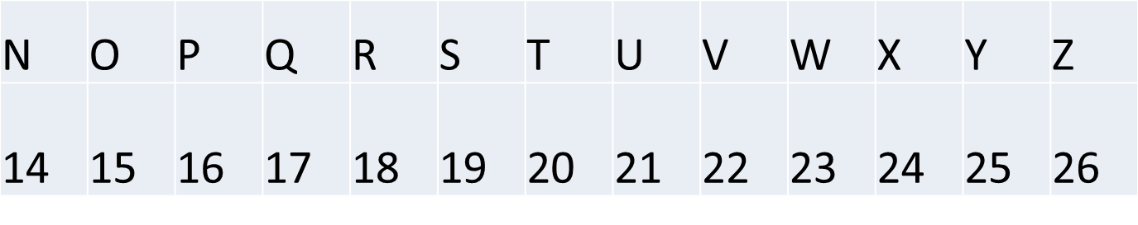

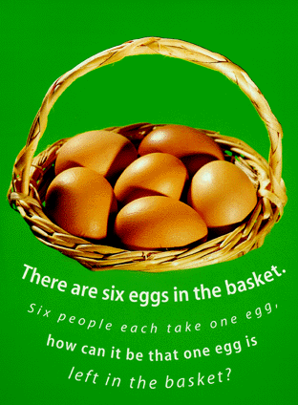

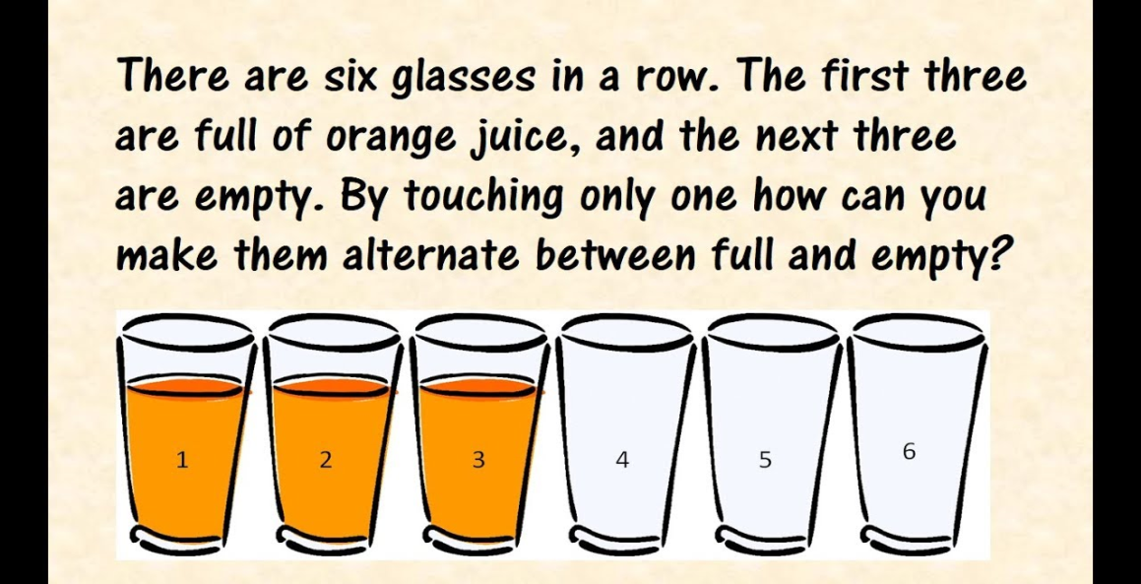

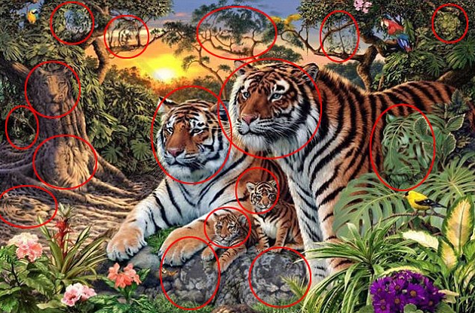 

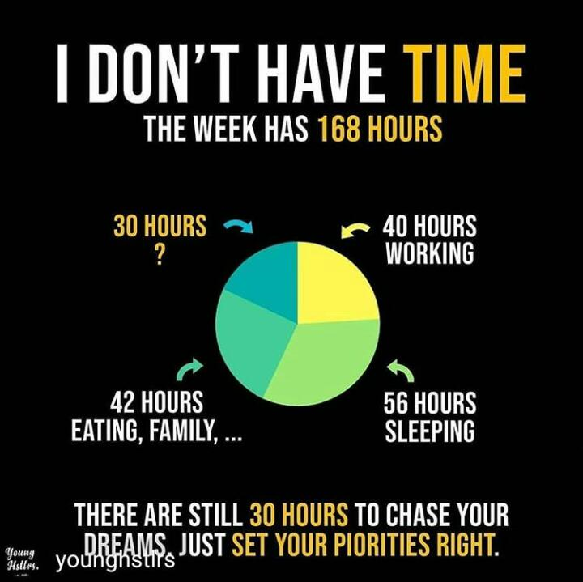

Errors are good – Learn from mistakes

Thomas Edison tried two thousand different materials in search of a filament for the light bulb. When none worked satisfactorily, his assistant complained, “All our work is in vain. We have learned nothing.”

Edison replied very confidently, “Oh, we have come a long way and we have learned a lot. We know that there are two thousand elements which we cannot use to make a good light bulb.”

I am having two coins of Indian currency in my pocket, the total value of which comes to 75 paisa. But mind you, one of the coins is not a fifty paisa coin. How it is possible? 

<https://www.youtube.com/watch?v=Mjzes6aqDw4&feature=youtu.be> – Trust yourself – Practice Makes the man perfect

<https://www.youtube.com/watch?v=07d2dXHYb94&feature=youtu.be>